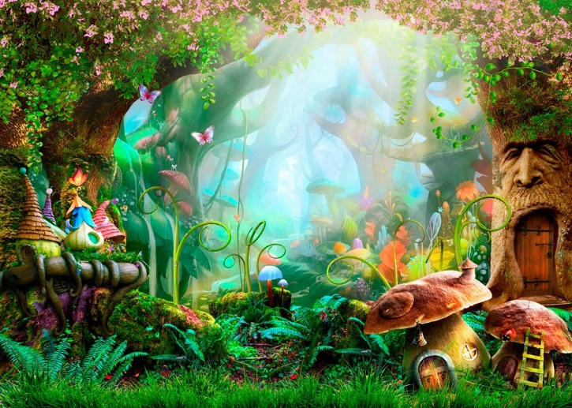
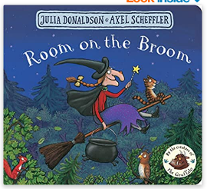
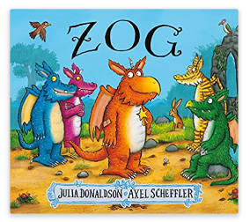
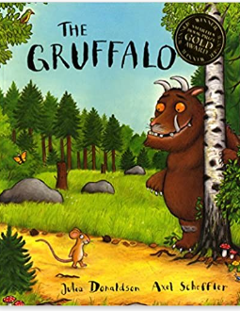
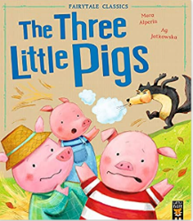
Magical Dragons, Surprising Spells and Enchanted Forests…
Key Texts

Retrievable Knowledge
- Describe events in some detail.
- Use new vocabulary in different contexts.
- Explore numbers 0-5
- Hear and identify initial sounds in words
- Hold a pencil correctly
Memorable Knowledge
- Understand the effect of changing seasons on the natural world around them.
- Understand how fiction stories are structured
- To write alternative endings
- Listen to and talk about selected non-fiction to develop a deep familiarity with new knowledge and vocabulary
- Compare weight and capacity
- Explore 2D shapes
Key Vocabulary
Potion | A mixture of liquids
Spell | verbal formula believed to have magical force
Enchanted | Placed under a spell. Having a magical quality.
Fairy tale | Children’s story in a magical setting
Magical | Producing magic
Mysterious | Strange, unknown, or hard to understand or explain.
Arctic | The region around the North Pole
Glacier | A slow moving mass or river of ice formed by the accumulation of snow
Hibernate | Spend the winter in a dormant state

